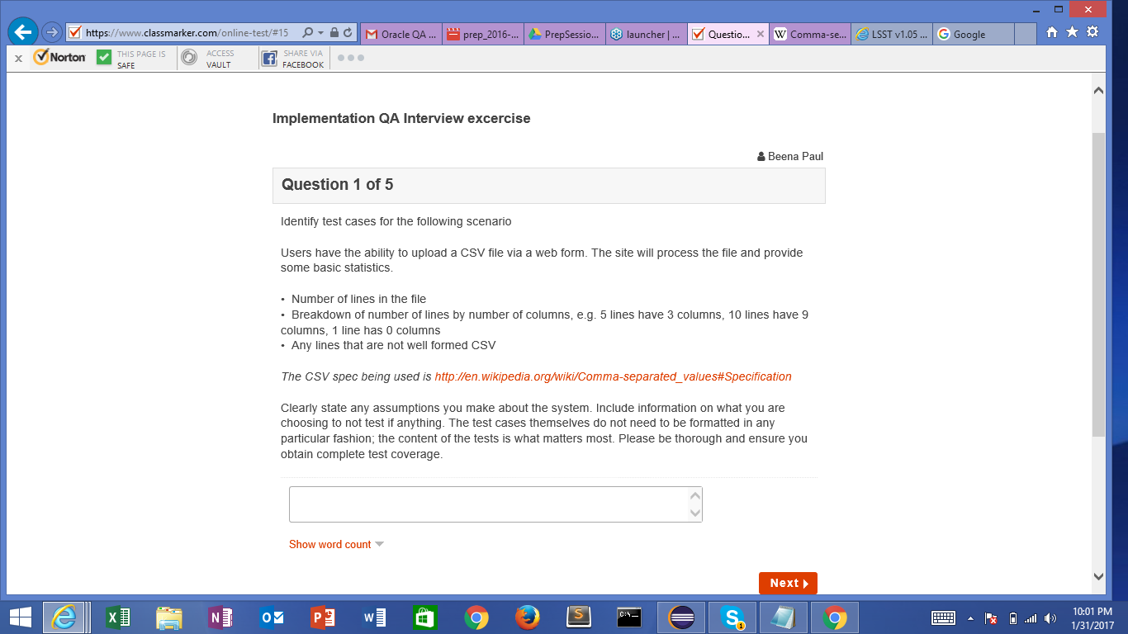

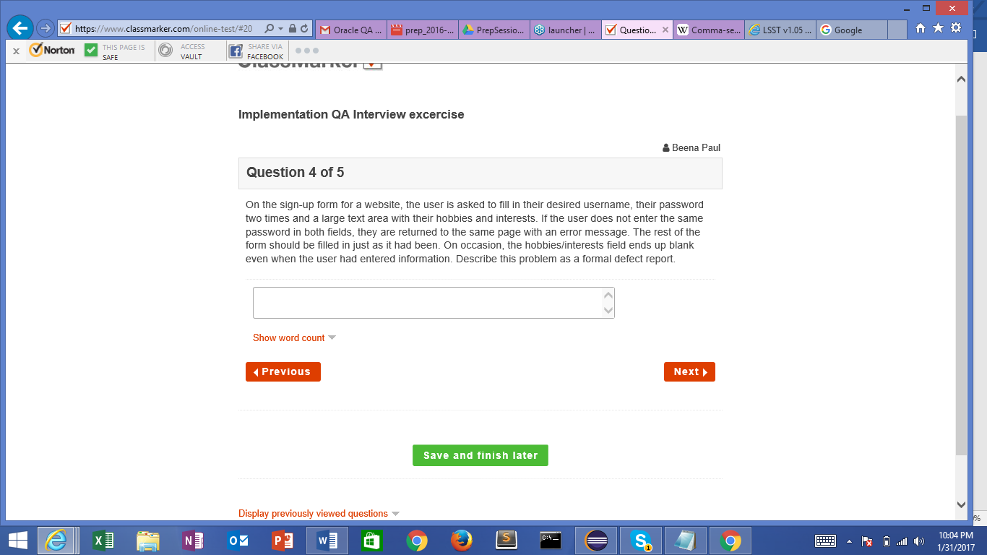

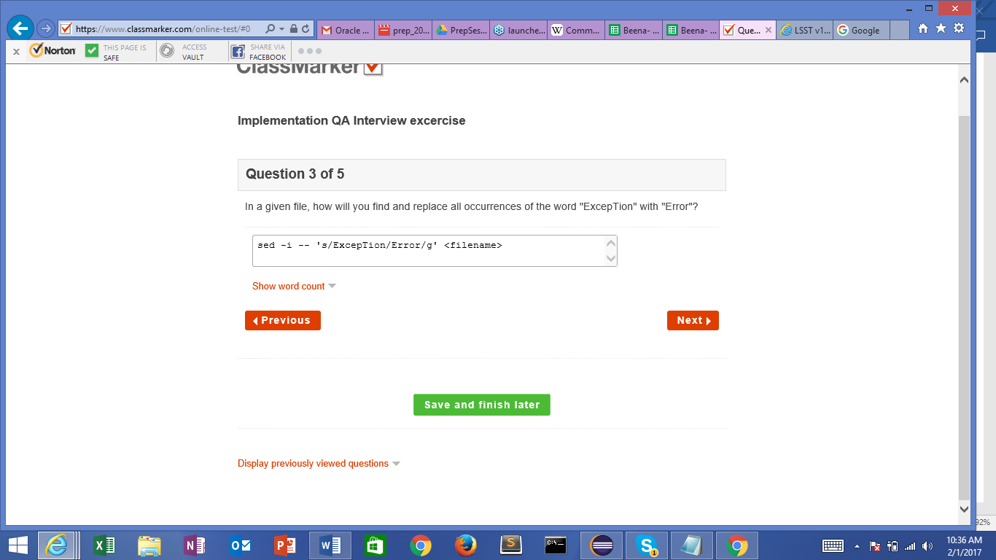

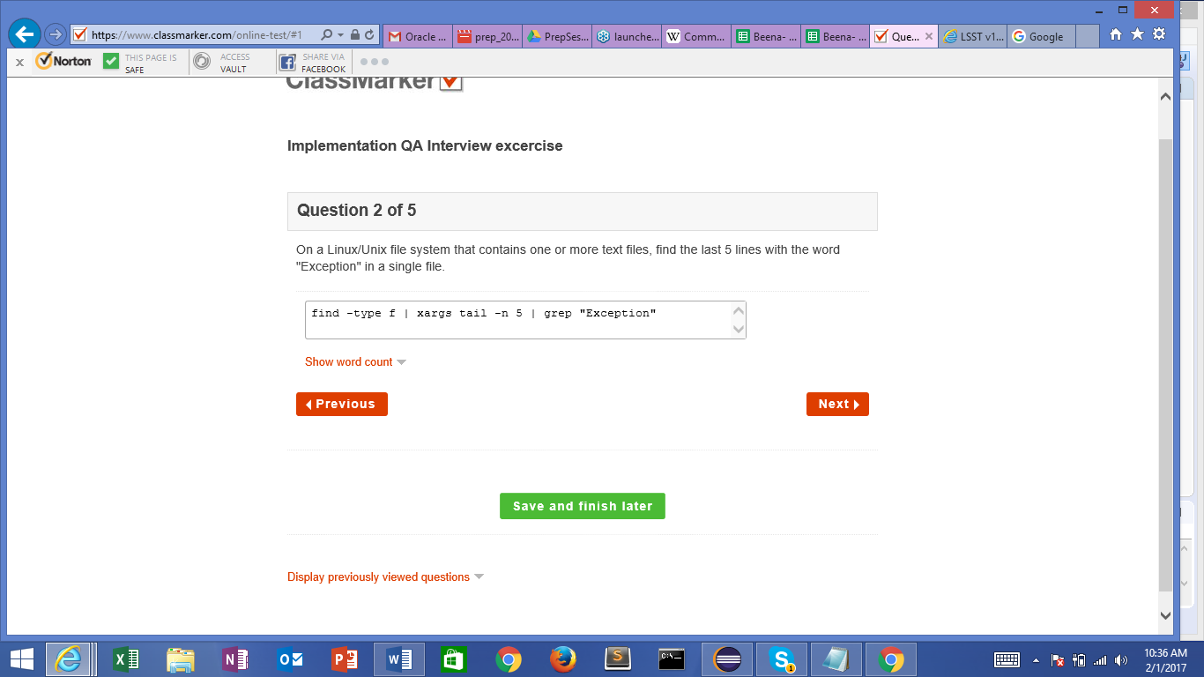

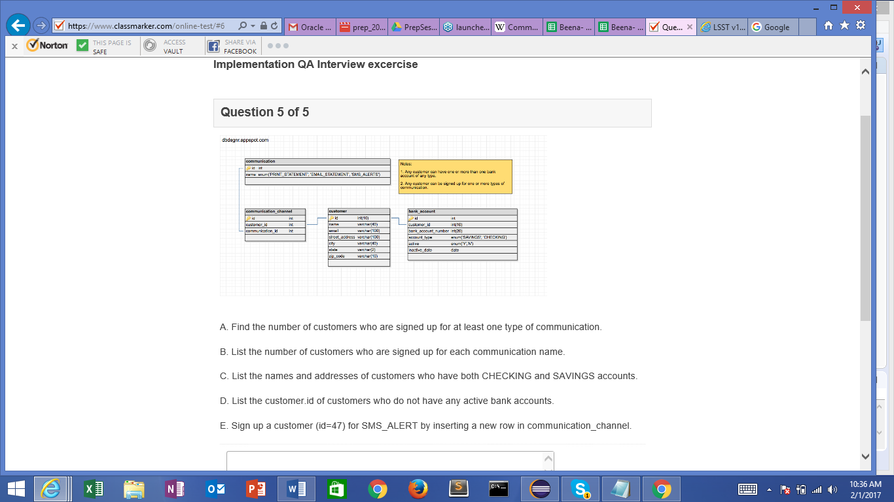

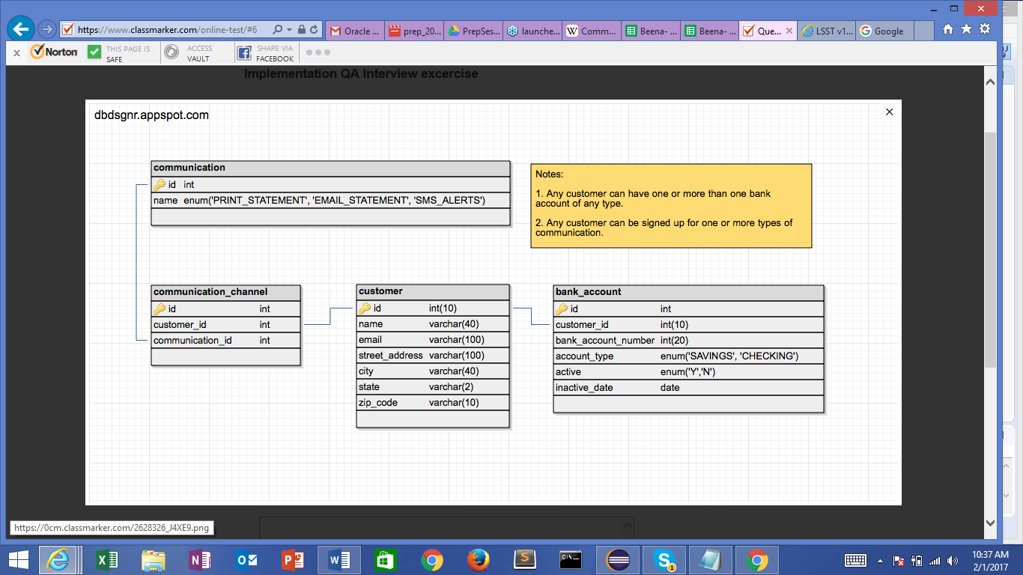

create table communication

(id number(6) primary key

,name varchar2(20))

create table communication_channel

(id number(6) primary key

,customer_id number(6)

,communication_id number(6))

create table customer

(id number(10) primary key

,name varchar(40)

,email varchar(100)

,street_address varchar(100)

,city varchar(40)

,state varchar(2)

,zip_code varchar(10)

)

create table bank_account

(id number(10) primary key

,customer_id number(10)

,bank_account_number number(20)

,account_type varchar(10)

,active varchar(1)

,inactive_date date

);

insert into communication values (1,'PRINT_STATEMENT');

insert into communication values (2,'EMAIL_STATEMENT');

insert into communication values (3,'SMS_ALERT');

insert into communication_channel values (11,111,1);

insert into customer values (111,'tom','t@gmail.com','tadd','tcity','ts','5000');

insert into bank_account values (43,222,45678,'SAVINGS','N','22-FEB-16');

1.)select count(*) from customer c join communication_channel ch

on c.id = ch.customer_id

join communication co

on co.id=ch.communication_id

where co.name IN ('PRINT_STATEMENT','EMAIL_STATEMENT','SMS_ALERT');

2.) select count(*),co.name from customer c join communication_channel ch

on c.id = ch.customer_id

join communication co

on co.id=ch.communication_id

group by co.name;

3) SELECT c.name,c.street_address

FROM customer c INNER JOIN

(SELECT customer_id, COUNT(DISTINCT account_type)

FROM bank_account

GROUP BY customer_id having COUNT(DISTINCT account_type) >1 )b

ON c.id=b.customer_id;

4)

select c.id from customer c

join bank_account b

on c.id = b.customer_id

where b.active = 'N';

5) insert into communication_channel values (77,47,30);

select * from communication_channel;